**Switzerland to replace FITs with solar rebates in 2018**

**https://www.pv-magazine.com/2017/12/06/switzerland-to-replace-fits-with-solar-rebates-in-2018/**

According to Swissolar, this change will allow more PV capacity to be deployed, as waiting times for the implementation of FIT contracts are considerably increasing. Self-consumption is also becoming more attractive for multi-family houses and commercial enterprises.

DECEMBER 6, 2017 [**SANDRA ENKHARDT**](https://www.pv-magazine.com/author/sandraenkhardt/)

* [COMMERCIAL & INDUSTRIAL PV](https://www.pv-magazine.com/category/installations/commercial-industrial-pv/)
* [HIGHLIGHTS](https://www.pv-magazine.com/category/highlights/)
* [MARKETS](https://www.pv-magazine.com/category/markets-policy/markets/)
* [RESIDENTIAL PV](https://www.pv-magazine.com/category/installations/residential-pv/)
* [SWITZERLAND](https://www.pv-magazine.com/region/switzerland/)

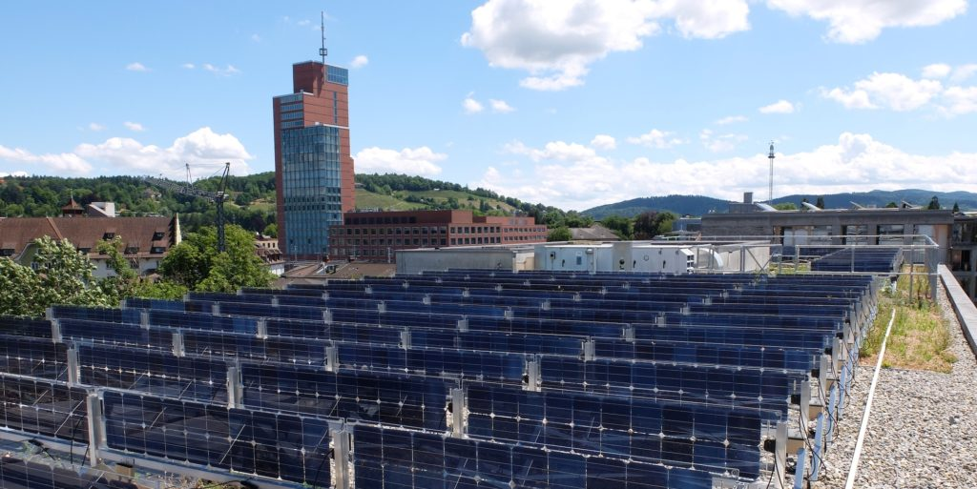

Source: Solarspar

Switzerland’s regulatory framework for the promotion of PV will change starting in 2018. According to the Swiss Photovoltaic Association Swissolar, the current FIT scheme (KEV) for residential and commercial PV will be replaced with a rebate scheme (EIV).

From 2018, FITs will be paid only to projects that were registered for a FIT contract before mid-2012. All other PV systems will be funded through the EIV, which will guarantee a maximum of 30% of the investment costs, according to Swissolar.

With these new provisions, the number of supported projects could considerably increase. So far, the investment subsidy has been paid only for PV systems not exceeding 30 kW in size.

In recent years, a huge waiting list has been set up under the FIT scheme in the Alpine Republic. According to Swissolar, it contains around 38,000 PV projects, which are now being treated preferentially in the payment of the EIV. New applicants would, therefore, have to be patient, with projects up to 100 kW having to wait about 2.5 years.

However, these systems could already be installed without the commitment of the funding agency, according to Swissolar. For PV systems over 100 kW, the waiting period may be of more than six years. According to the association, there is no financial risk for the investors in both cases, as the payment of contributions is guaranteed by law.

In addition, the new regulations will in the future allow collective projects for self-consumption. The simplified scheme also allows higher self-consumption rates, which makes these models more economically interesting for multi-family houses and commercial real estate, said Swissolar.

The calculation for the remuneration of surplus solar power, which continues to be fed into the grid despite optimized self-consumption, is newly regulated in the law. In many distribution areas, an increase in these “return rates” is to be expected.

In Switzerland, power providers set these tariffs for their areas independently, which is why they have differed widely regionally so far. According to reports from the Swiss Association of Independent Energy Producers (VESE), this year’s average was 0.09 CHF (US€0.0855) per kWh. However, tariffs ranged from 0.04 CHF to 0.14 CHF per kWh.